*Coral S. Schmidt #148830*

*Assignment 4.1*

*In their book Introduction to Linear Regression Analysis (4th. Edition, Wiley, 206), Montgomery, Peck, and Vinning presented measurements on NbOCl3 concentration from a tube-flow reactor experiment. The data, in gram-mole per liter x 10-3, are as follows. Compute the sample mean, the sample variance, the sample standard deviation, the range and the Normal Probability Plot.*

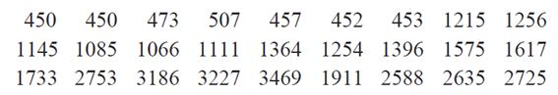

1. What is the sample mean?



1. What is the sample variance?



1. What is the sample range?



1. Construct the Normal Probability Plot.

